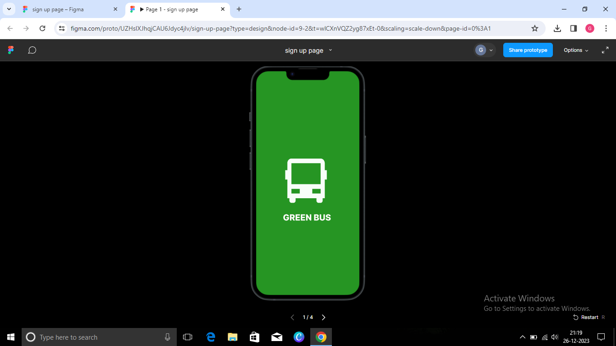

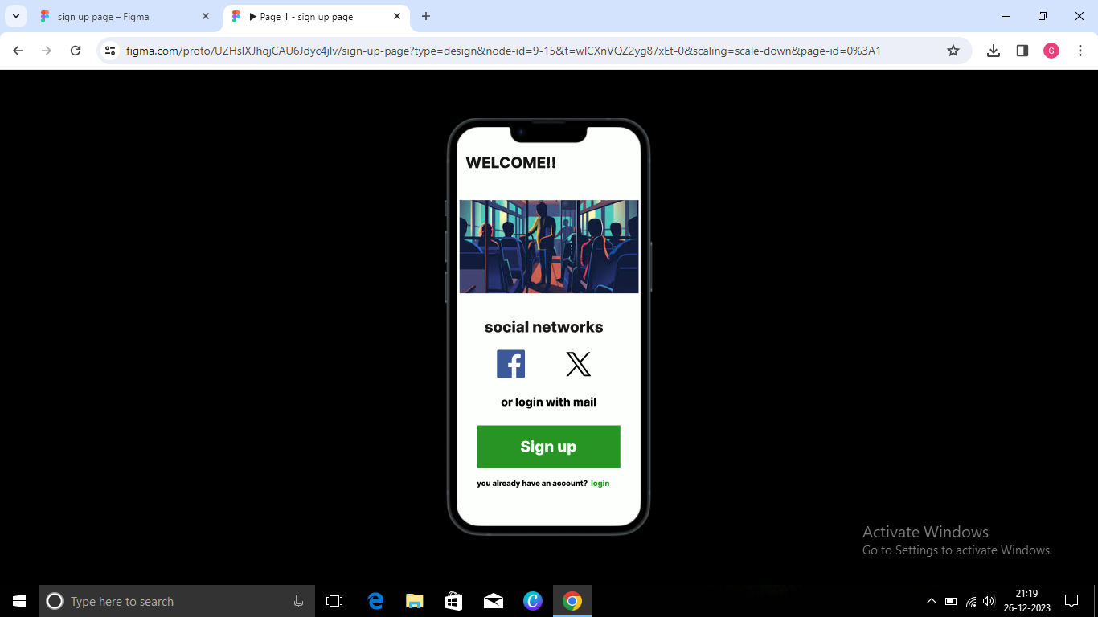

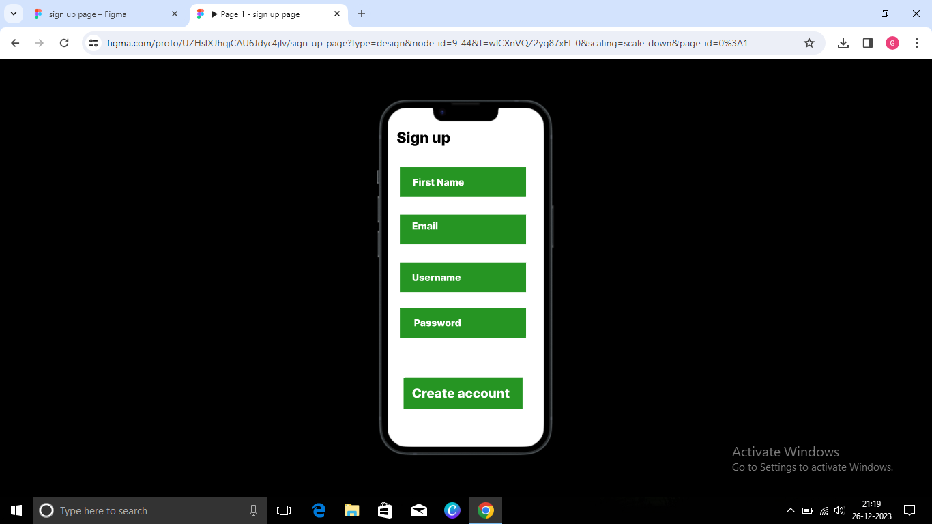

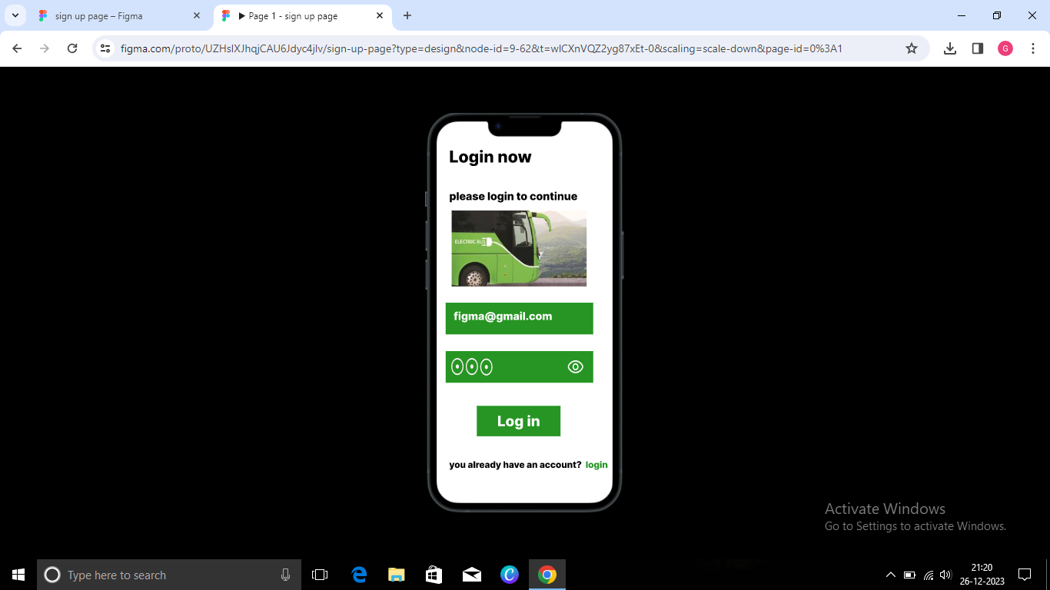

<https://www.figma.com/file/UZHsIXJhqjCAU6Jdyc4jlv/sign-up-page?type=design&node-id=0-1&mode=design&t=ReATiXZXYJesRVsM-0>